1. 
2. 
3. 
4. 
5. All URLs are secured by default.
6. 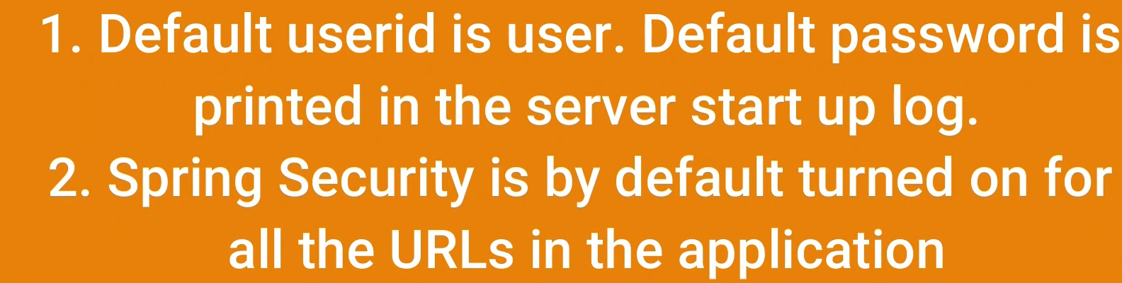
7. 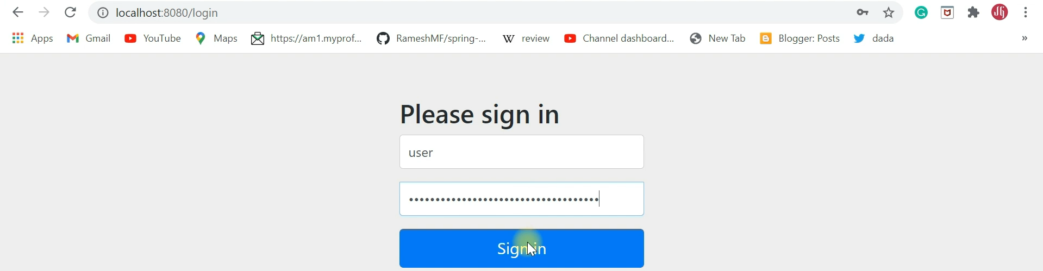
8. 